1. Command to one bear. Command this bear to act. | 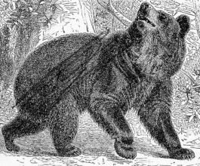
2. Command to three deer. Command these deer to act. | 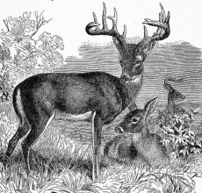
3. Statement of Present activity. Describe in a simple statement what this squirrel is doing. | 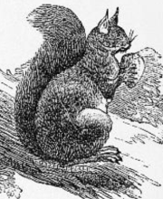
4. Statement of Present activity. Describe in a simple statement what these beavers are doing. | 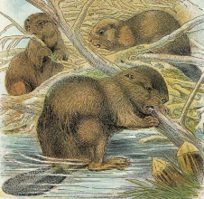
5. Statement of Present activity. Describe what you and this fox are doing. | 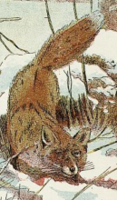
6. Statement of Present activity. Describe what you and these mice are doing. | 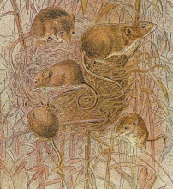
7. Statement of Habitual activity. Describe what this turtle always does. | 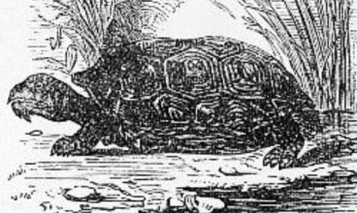
8. Statement of Habitual activity. Describe what these flying squirrels always do. | 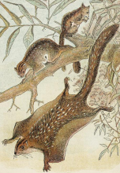
9. Statement of Habitual activity. Describe what you and this rabbit always do.  Nigohilv tsisdu dosdihnogisgoi.  Nigohilv tsisdu dosdatsidohoi. we run around | 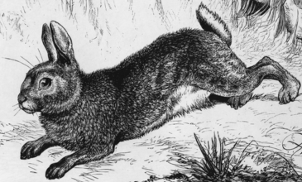
10. Statement of Habitual activity. Describe what you and these raccoons always do.  Nigohilv kvhla dotsihnogisgoi.  Nigohilv kvhla otsadawosgoi. | 